Lab 02.4 – Dockerfile

Thực hành
Tạo thư mục:
mkdir apache
cd apache
Tạo file Dockerfile:
nano Dockerfile
FROM ubuntu:14.04

MAINTAINER mssv

RUN apt-get update && apt-get install -y apache2 && \
mkdir -p /var/run/apache2 && \
mkdir -p /var/lock/apache2 && \
apt-get clean && rm -rf /var/lib/apt/lists/*

ENV APACHE_RUN_USER www-data
ENV APACHE_RUN_GROUP www-data
ENV APACHE_LOG_DIR /var/log/apache2
ENV APACHE_PID_FILE /var/run/apache2.pid
ENV APACHE_RUN_DIR /var/run/apache2
ENV APACHE_LOCK_DIR /var/lock/apache2
ENV APACHE_SERVERADMIN admin@localhost
ENV APACHE_SERVERNAME localhost
ENV APACHE_SERVERALIAS docker.localhost
ENV APACHE_DOCUMENTROOT /var/www

EXPOSE 80

CMD ["/usr/sbin/apache2", "-D", "FOREGROUND"]

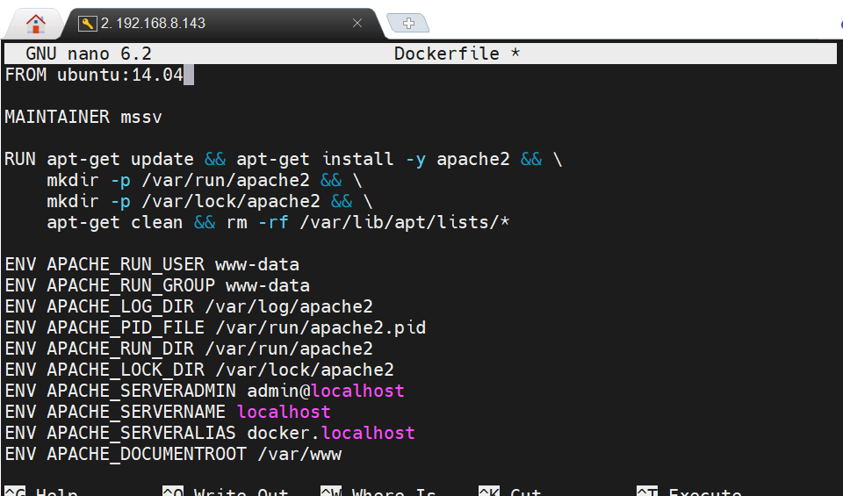
Tạo image từ container:
docker build -t apache_test .

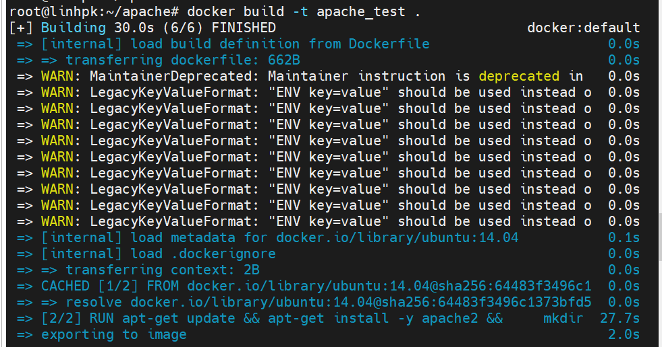

Kiểm tra image có tên apache_test vừa tạo
docker images

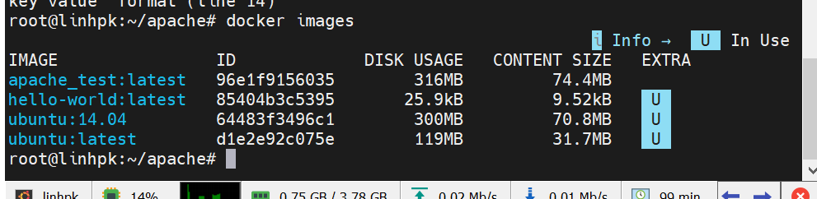

docker run -it -p 8080:80 apache_test
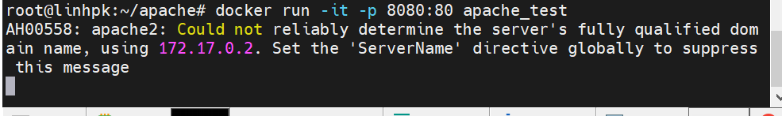

http://localhost:8080
